The article emphasizes how little data is organized correctly, this might seem like a trivial task when the size of information is small, but when it comes to enormous data sets, it can be nothing short of a nightmare. Nobody wants to do any job outside the scope of their role (in an ideal world), but it's honestly sad that most data analysts spend 80% of their time just prepping the data so their models can consume them and spit out a desirable & fancy output. I understand that managing data is not as "cool" as running predictive models to get to their "aha" moments, but without the correct form of data, one might take forever to get to those points.

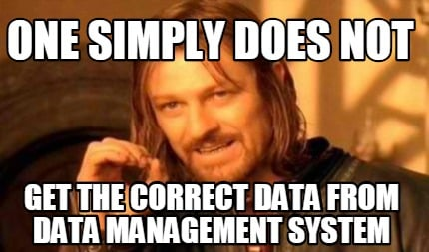

There are a lot of factors that need to be considered before picking an offensive or defensive strategy, but the most important ones can be seen below:

**Offensive:** If the company is customer-facing and needs to get insights into their sentiment to come up with ideas that produce higher revenue or profit.

**Defensive:** For companies that look for solid regulations trying to minimize the risks, such as fraudulent transactions, to prevent theft.

It's tricky to assume all companies need just one of these strategies or an equal 50/50 split. Even if the companies' business objectives are different, parts of their data require controlled access. Not everyone can access everything. In order to achieve these results, the data has to be uniform. Here Defensive strategy is needed. Whereas some parts of the data may need to handle a real-time request, data has to be flexible enough to undergo transfers and interpretations. In these cases, an Offensive strategy has to be used.

Let's consider Banks or Hospitals maintain records of patients' or customers' personal information. We have to implement Defensive methods as these require strong regulation. For intense competition to determine who else in the market could be a possible competitor and how to overcome such situations can be performed with an Offense strategy. Companies' current position is also a factor that has to play a role in deciding if they take the Defensive or Offensive approach.

When data is control oriented and centralized, it cannot be easy to implement a broad data strategy. If the data is flexible, it could be hard to customize. To improve flexibility and have a realistic approach to data architecture and information architecture, one must have both SSOT to support data and MVOT to support information, thereby allowing Defensive or Offensive data strategy.

SSOT can be implemented when data is cloud-based, virtual, access controlled with a common language, with a set of rules predefined and removing redundant systems. Robust technologies play an essential role, and rightfully so because there is no room for error. Centralized data allows daily operations to be carried out efficiently and with minimum errors.

MVOT, on the other hand, is something that is derived from SSOT. It requires a proper set of rules that can be used to derive the MVOTs from SSOT. Having a clear set of data definitions and data rules is vital. Any system can increase performance when feedback is appreciated, and considerable actions are taken.

Data Lakes are an ideal system to implement SSOT and MVOT, with their growing popularity and ability to accommodate ever-growing data. We could also use a Data warehouse to perform some Defensive operations that can have tight security and access control.

I want to consider Telsa as the company for this assignment section. Telsa is predominantly customer-facing, and with their self-drive feature, they collect a lot of information every second of every day. I believe Tesla would primarily focus on a Defensive approach when handling customers' data, like location information. In contrast, it could have an Offensive approach when dealing with the other information collected to predict and improve their current AI model.